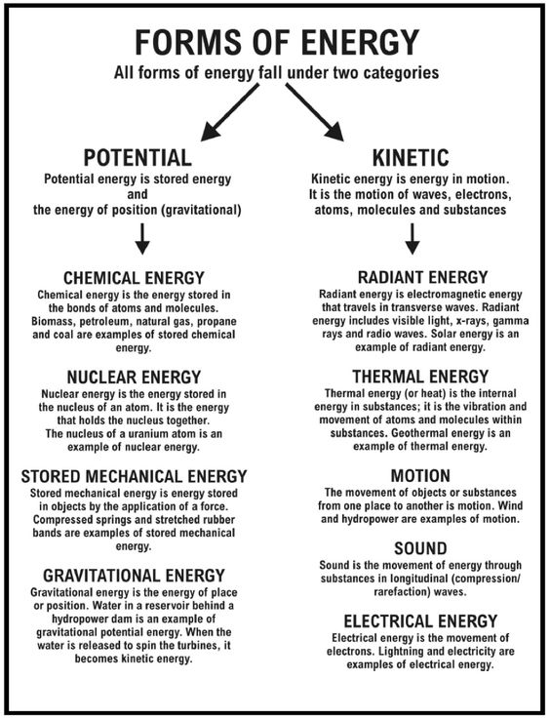
NAME_____________________________ PERIOD _______________ DATE ______________________

Energy Review Worksheet
Complete the following worksheet on a separate sheet of paper. Use your textbook to help you.

1. What is energy?

2. What are the different forms of energy?

3. Compare kinetic and potential energy.

4. What causes kinetic energy to increase?

5. What causes potential energy to increase?

6. What is the law of conservation of energy?

7. How does heat flow?

8. Explain why your hand gets cold when you hold ice.

9. Explain why your hand gets hot when you hold a cup of hot chocolate.

10. Identify the energy transformations that take place in the following examples:
a. Driving a car

b. Burning wood

c. Turning on a television

d. Eating breakfast before school

