
Diffusion, Osmosis and Active Transport Worksheet
Name…………………………………………………… Date………………

1. Which type(s) of transport is each statement true for? Add ticks to the correct boxes.

 | Diffusion | Osmosis | Active Transport
A substance moves from an area of low concentration to an area of high concentration.
Can happen in living cells.
A substance moves and becomes more evenly spread out.
The movement does not use energy and is caused by the random movement of individual particles. | .
The movement requires energy from respiration.
Only water is involved in this type of movement.
Water moves from a less concentrated solution to a more concentrated solution.

- Choose a word from the box at the bottom of the page to fill in the gaps in the sentences below. You can use words once, twice or not at all.
In animals, oxygen …………….……… into cells across cell membranes to be used in ……………………..…. Carbon dioxide …………………… out of cells.
In plants, carbon dioxide diffuses into cells to be used in ………………..……….
Water enters the roots of plants by ……………………. Water moves into cells through …………………… permeable membranes, which allow small molecules, such as water, to pass through, but not large molecules.
Plants use a process called …………………..… to move minerals such as nitrates into
root cells. This requires …………………….
diffuses
photosynthesis
osmosis
respiration
partially
active transport
energy
1
© Boardworks 2015
- The diagrams below show substances at different concentrations, separated by a membrane. Out of each pair, say which one will have a faster diffusion rate, and explain why.
glucose =
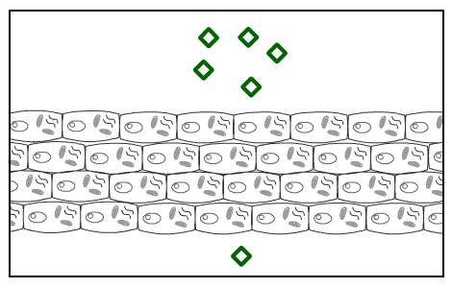
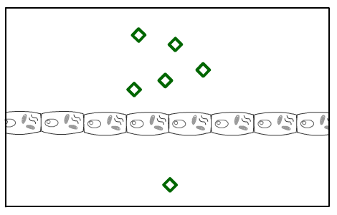
a) i) ii)

..............................................................................................................................................
..............................................................................................................................................
..............................................................................................................................................
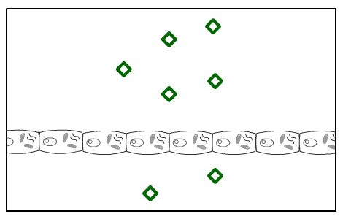
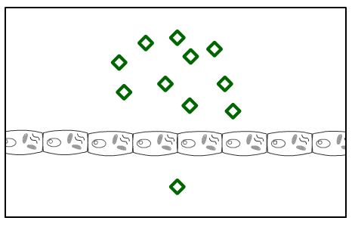
b) i) ii)

..............................................................................................................................................
..............................................................................................................................................
..............................................................................................................................................
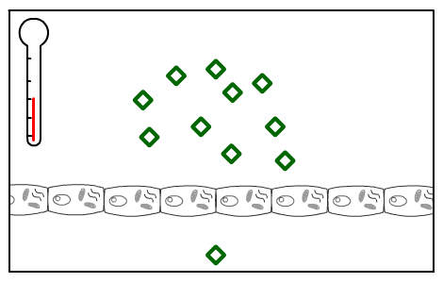
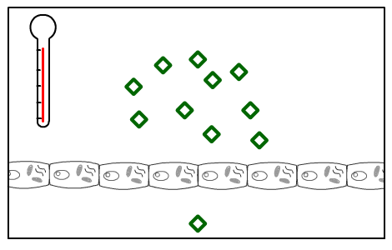
10°C
30°C
c) i) ii)

..............................................................................................................................................
..............................................................................................................................................
..............................................................................................................................................
2
© Boardworks 2015

- The experiments below show visking osmometers, which are used to
measure osmosis. Visking tubes are partially permeable.

The experiments below all involve different solutions. They were left for a day. The water level at the start of the day is shown. Mark on each diagram where you think the liquid levels will be after one day.
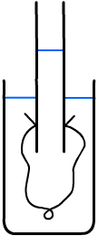
a)
b)
glass tubing

water at the start of the day

secured with knot

visking tubing

1 M glucose solution

1 M glucose solution

5 M glucose solution

distilled water

c)
d)

1 M glucose solution

2 M glucose solution

distilled water

5 M glucose solution

3
© Boardworks 2015

- A student set up an experiment to investigate osmosis in potatoes. He cut six chips which are approximately 5 cm × 1 cm × 1 cm and recorded the mass of each. He placed each chip in a sugar solution of a different concentration. After a day he recorded the mass of each potato chip again. His results are shown in the table below.
Glucose concentration (M) | Change in mass (g)
0.0 | +10.2
0.1 | +6.0
0.2 | +1.9
0.3 | -10.7
0.4 | -16.1
0.5 | -20.2

a) Draw a graph of these results.
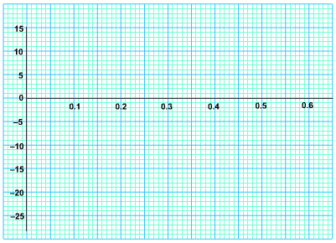

change in mass (g)

concentration (M)

b) Explain why the mass of the potato changed during the experiment.

...................................................................................................................................................
...................................................................................................................................................
...................................................................................................................................................

c) i) What is the approximate concentration of a potato cell?
………………

ii) Explain your answer.

..............................................................................................................................................
..............................................................................................................................................
4
© Boardworks 2015

